Medical Physics Minor
Department of Physics and Astronomy
www.physics.du.edu
303-871-2238

Are you considering medical, dental or other bio-related graduate school or program or a health-related career in the sciences or engineering?

If you have completed either General Physics or University Physics sequence, you need only 5 additional credits to earn a minor in Physics.

Medical Physics Minor is a two-course sequence that will satisfy this requirement:

PHYS 2300 Physics of the Body, Winter 2008, TR 2-3:30 PM, 3 credits.
Instructor: Davor Balzar (balzar@du.edu)
Main textbooks:
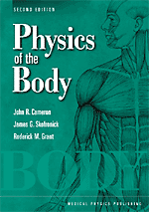
Physics of the Body by J. R. Cameron, J. G. Skofronick, and R. M. Grant, 2nd Ed., Medical Physics Publishing.

This book is intended primarily for students who plan to make a career in some field of medicine. The authors rely on basic physics principles to promote an understanding of the function of the various organ systems of the body such as the eyes, ears, lungs, and heart. Although it was written primarily as a text for students who have some knowledge of elementary physics, it will be interesting and understandable to any person who is curious about how his/her body works. The mathematics is at the algebra level.
(Reprinted from the Medical Physics Publishing Web site)

Physics in Biology and Medicine by P. Davidovits, 3rd Ed. Elsevier.

PHYS 2340 Medical Imaging Physics, Spring 2008, TR 2-3:30 PM, 3 credits.
Main textbook/resource:

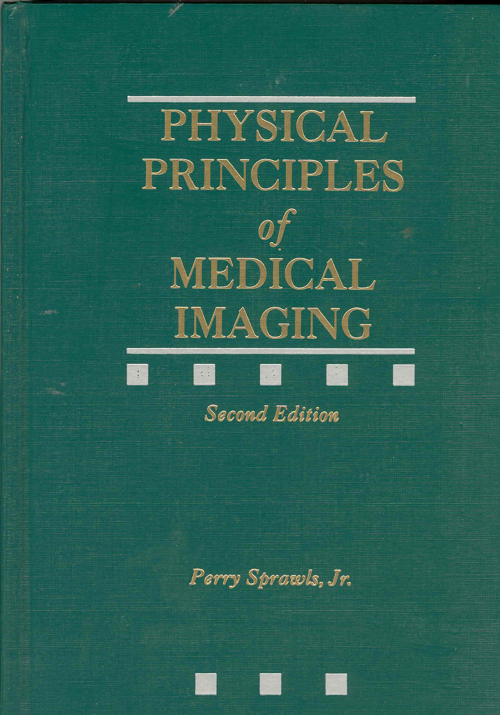
The Physical Principles of Medical Imaging, by Perry Sprawls, 2nd Ed.

Medical images are formed from the interaction of several types of radiation with the physical properties and functions of biological tissue. The course will cover the various energies, interactions, and technologies used to create medical images and the physical characteristics that define the images. Image quality, contrast and resolution for several imaging modalities will be compared and evaluated. Image information content as a function of the imaging process will be discussed. (Reprinted from the course syllabus)

